**10. WEIN BRIDGE OSCILLATOR**

**AIM** : To obtain the frequency of oscillations of a Wein Bridge oscillator.

**APPARATUS** :

1. 741 OP – Amp,
2. Resistors – 4.7K (2) & 10K (1),
3. Potentiometer 10K (1),
4. Decade Capacitances Boxes (2),
5. Bread Board and connecting wires,
6. CRO with probes,
7. TRPS

**CIRCUIT DIAGRAM :**

K

4.7

V0

K

4.7

K POT

10

-

15

-

+

LM741

3

4

6

7

2

DCB

K

4.7

+15

WEIN BRIDGE OSCILLATOR

**PROCEDURE** :

1. Connections are made as per the circuit diagram.
2. The two capacitances are varied by using variable capacitance box.
3. The output wave is observed on the CRO.
4. The time period of the wave for each value of capacitor is noted.
5. The frequency of the wave is calculated from the time period using the formula **f = 1/T**
6. Theoretical frequency is calculated by using the

Formula **f = 1/2П√R1R2C1C2**

1. Compare the practical and theoretical values.

**OBSERVATION** :

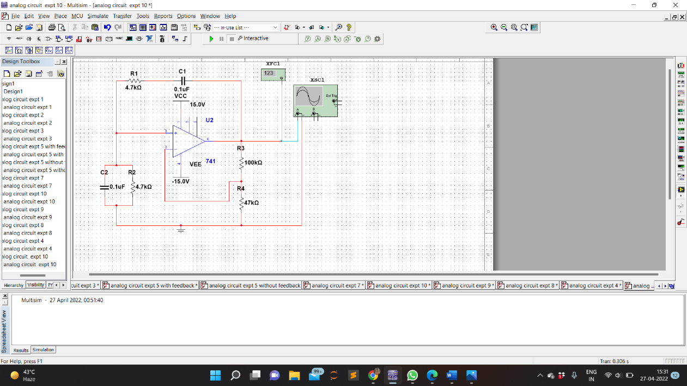CIRCUIT DIAGRAM

WAVEFORM OBTAINED

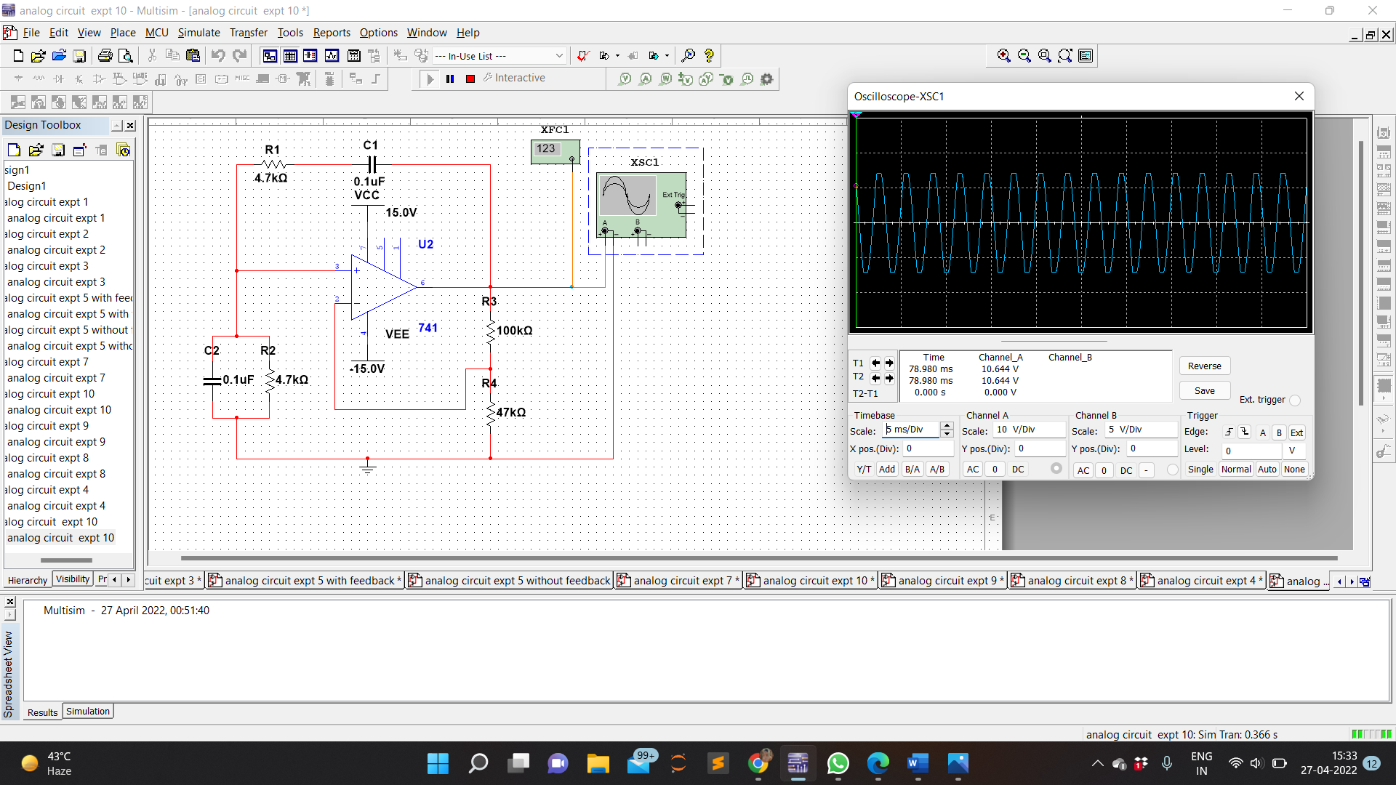

PRACTICAL FREQUENCY

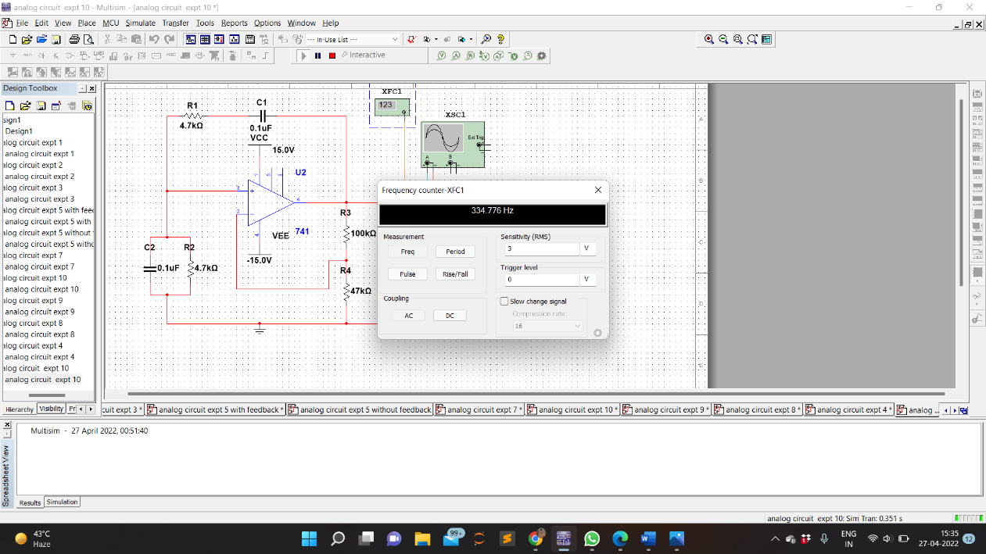

**CALCULATION :**

**TABULAR FORM** :

|  |  |  |  |  |  |
| --- | --- | --- | --- | --- | --- |
| **R1 = R2 (kΩ)** | **C** | | **Theoretical f = 1/2П√R1R2C1C2** | **Time Period**  **T (Sec)** | **Practical f = 1/T (Hz)** |
| **C1** | **C2** |
| 4.7    4.7    4.7 | 0.1µF    0.01µF    0.01 µF | 0.1µF    0.01 µF    0.1 µF | 338.799  3387.993  1072.149 | 0.002951  0.0002951  0.000933 | 334.776  3278  573.299 |

**PRECAUTIONS**

1. Avoid loose and wrong connections.

2. Connections should be made properly and theOutput should be a proper sine wave, such that the Time Period and amplitude may be obtained accurately.

**RESULT**:

Frequency of oscillations of a Wein Bridge oscillator is observed and studied for different values of capacitor through the designed circuit.